**Coding Challenge-5**

Date: **19/12/2024**

Name: **Harish E.R**

**Q) Buiild an etl pipline with azure synapse with dataflow running on**

**Making a dataflow to copy data from data lake storage to dataset:**

* **Create a Datalake storage account:**

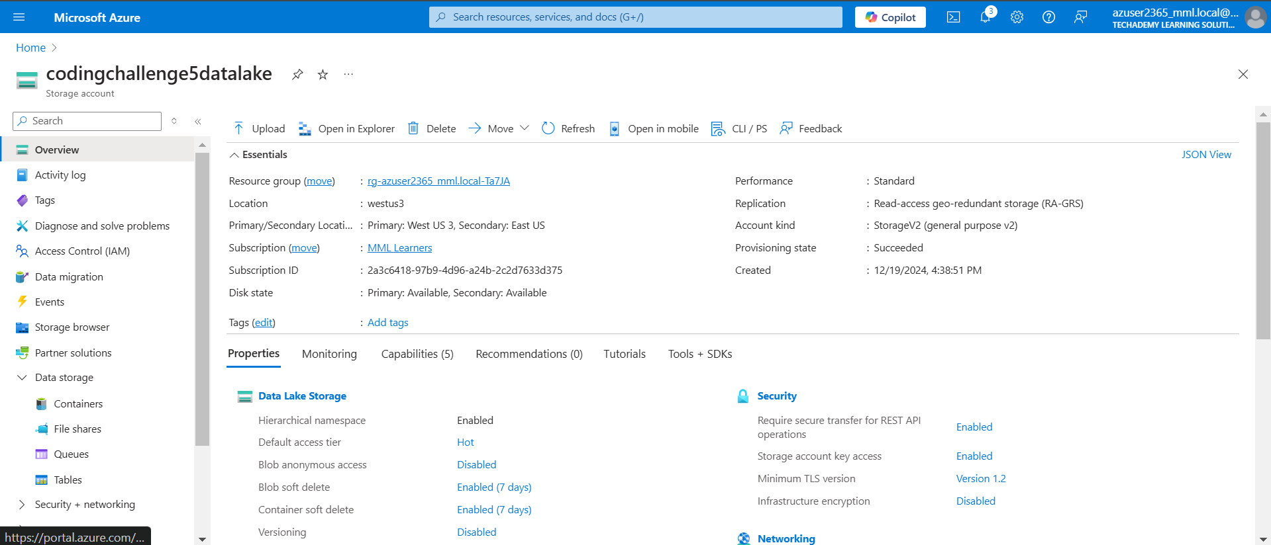

* **Upload a CSV file in container:**

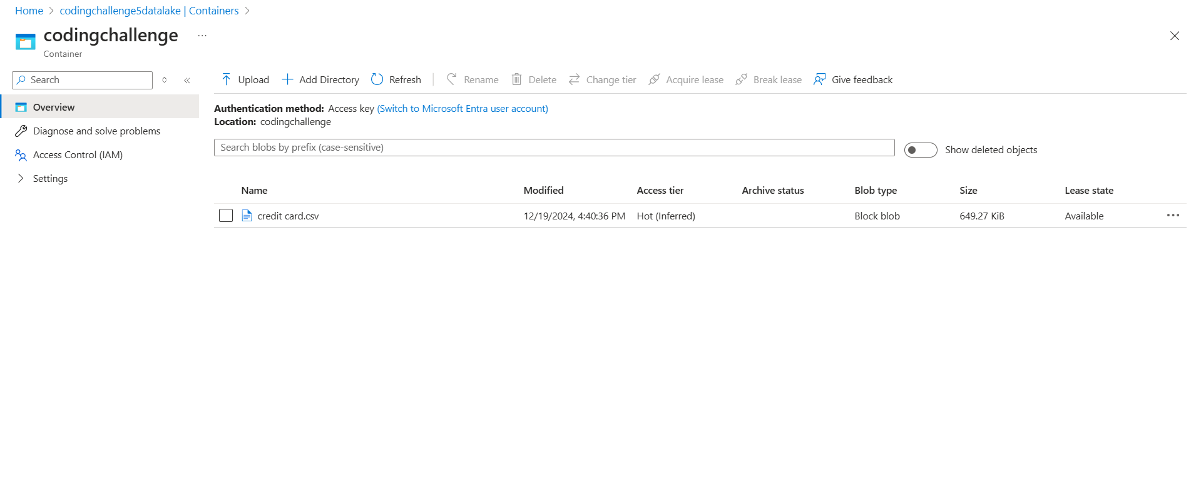

* **Create a Azure Synapse Account:**

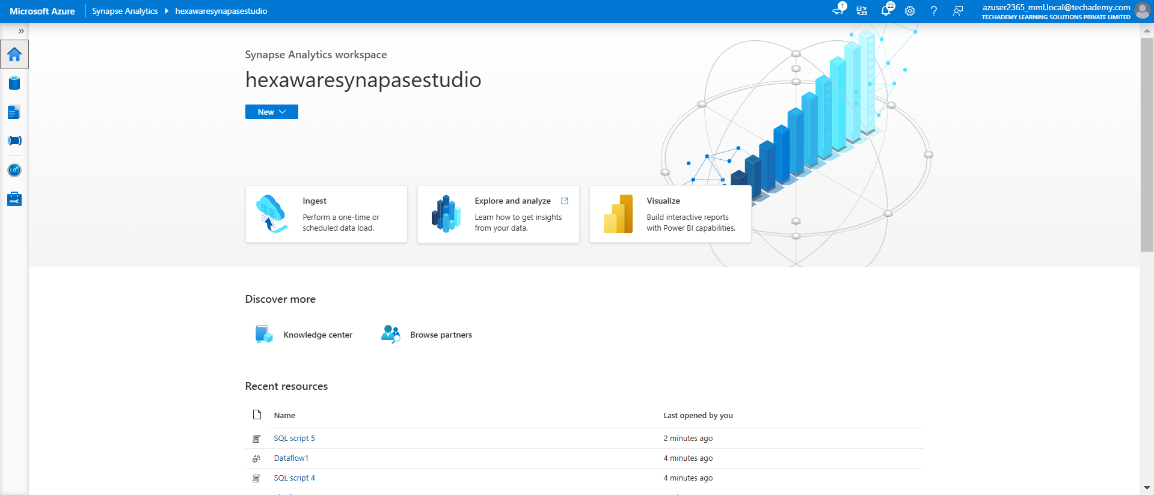

* **Link the Synapse with Data lake account:**

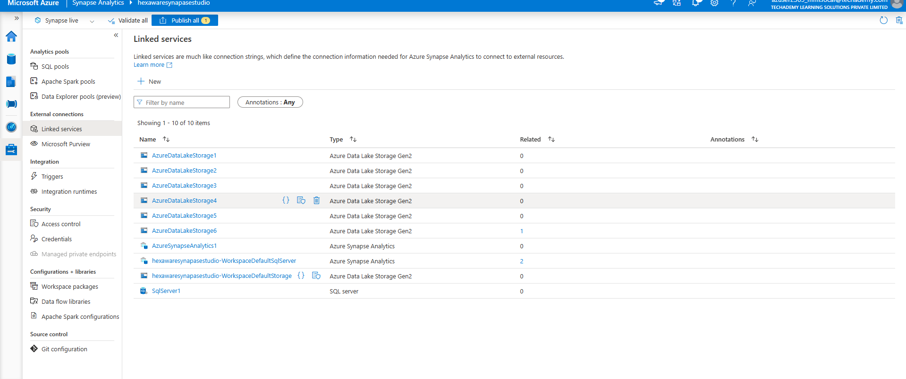

* **Make a new dataset in which data is to be copied:**

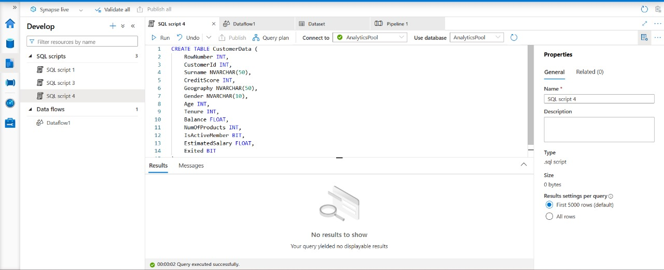

* **Make a dataflow:**

1. Source:

Use the source as the datalake account.

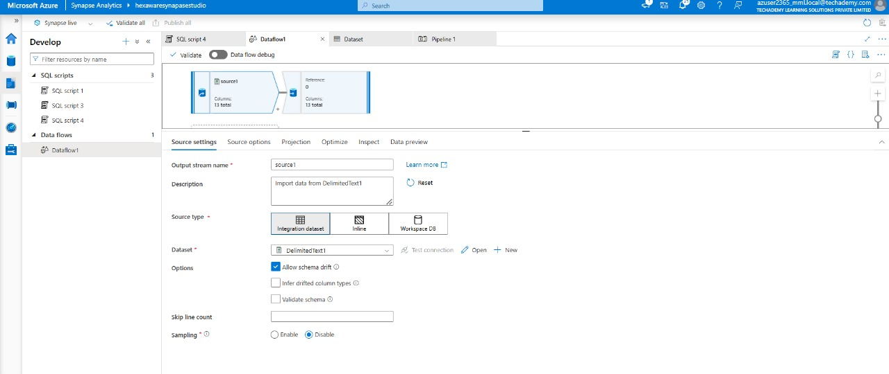

1. Sink:

Sink as the Synapse dataset which was created above.

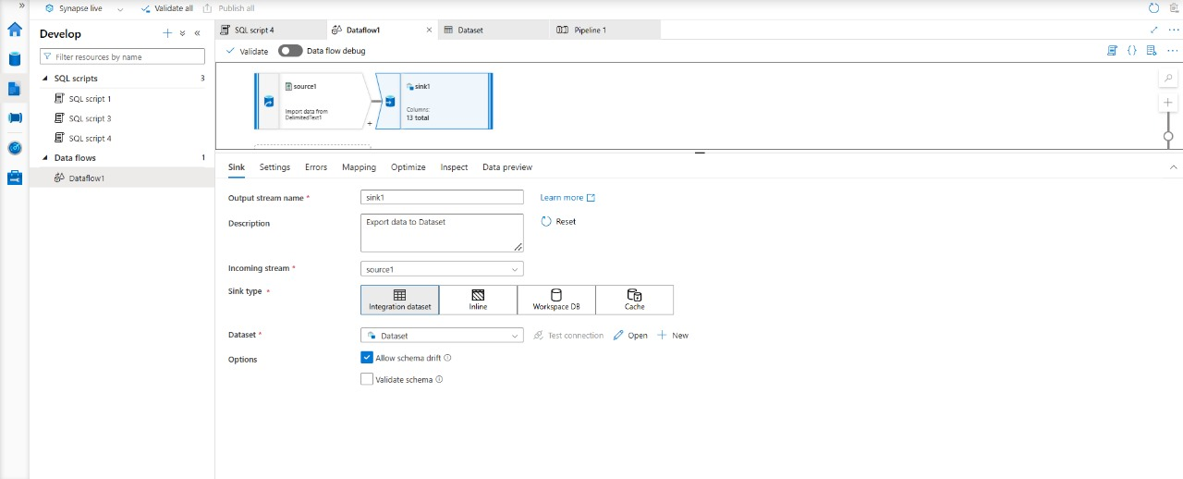

* **Publish the Dataflow**



* **Create ETL pipeline and trigger it:**

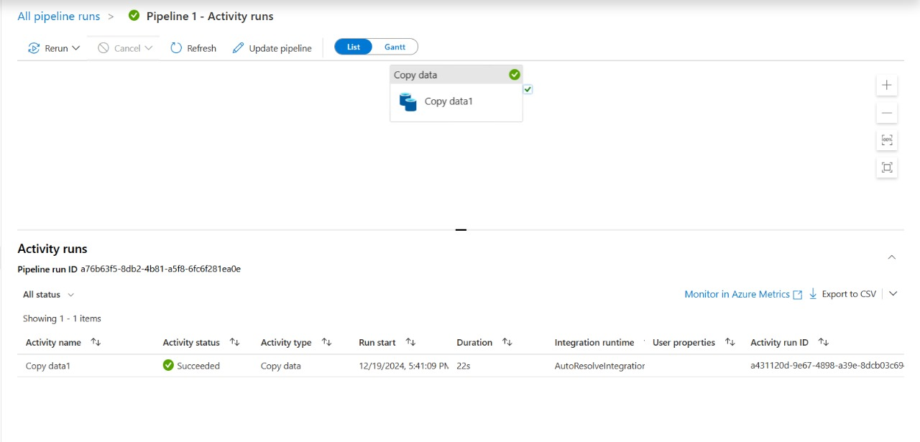

* **Check the dataset after running the pipeline:**

